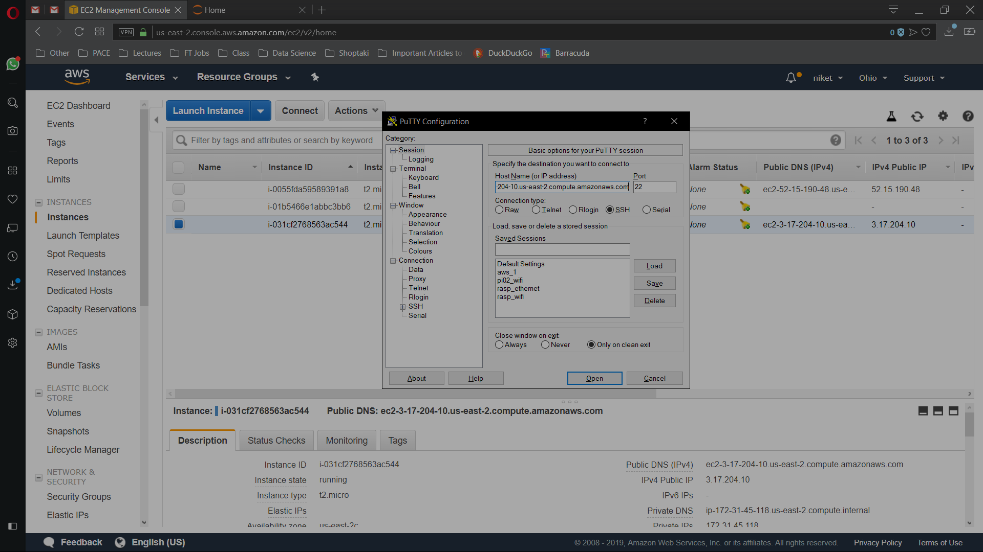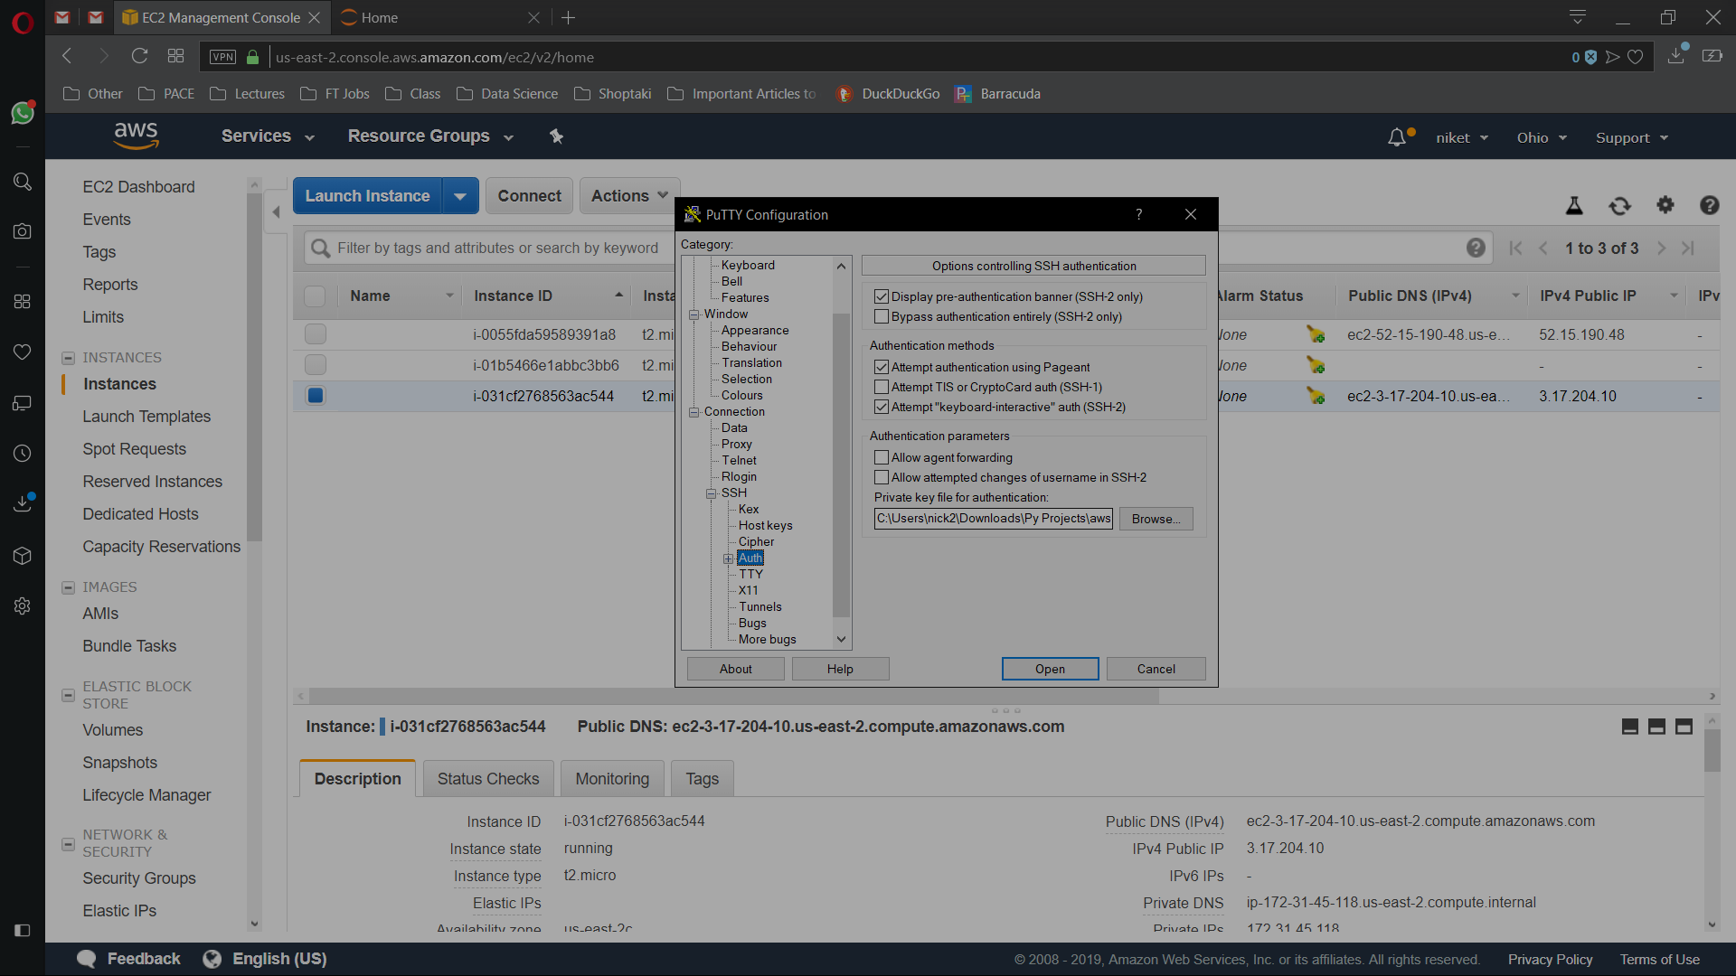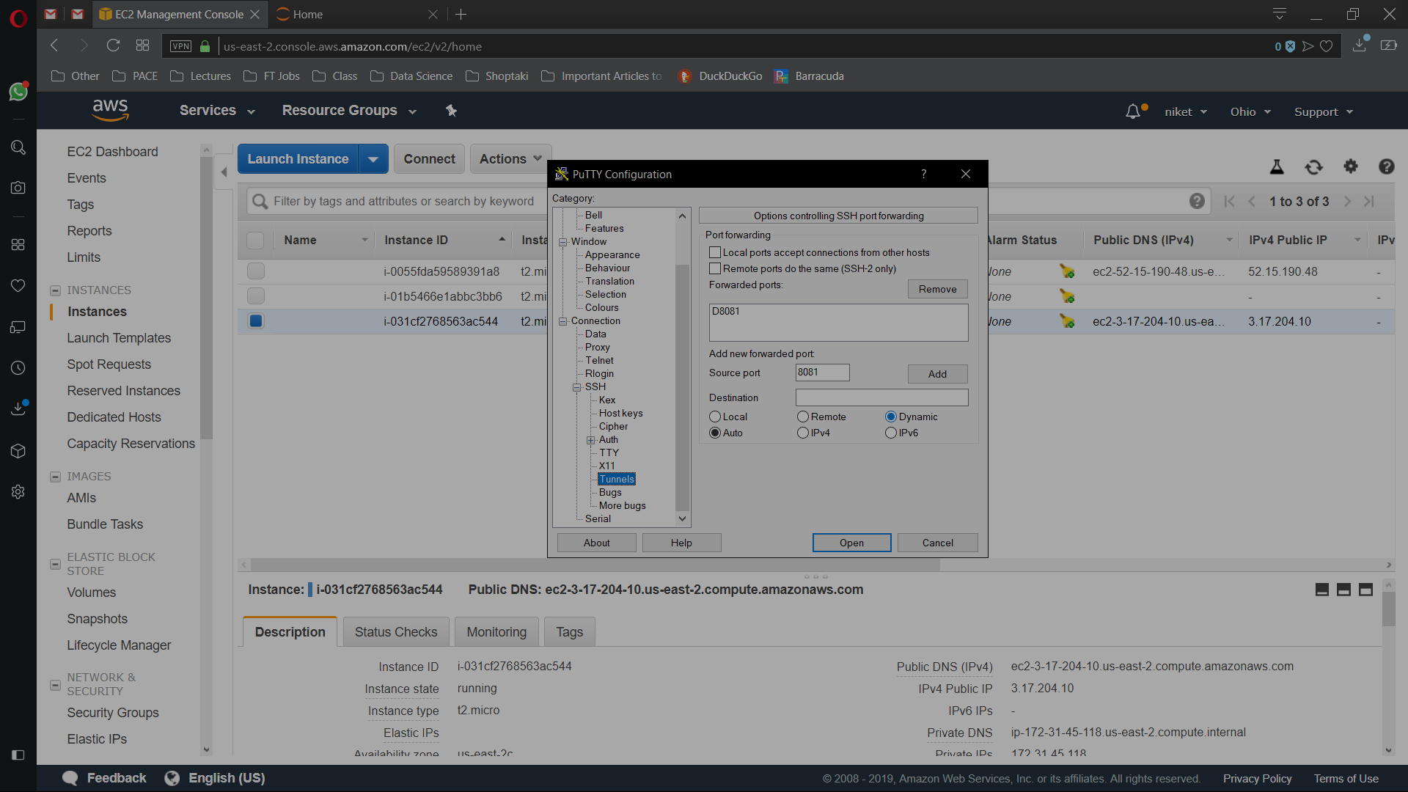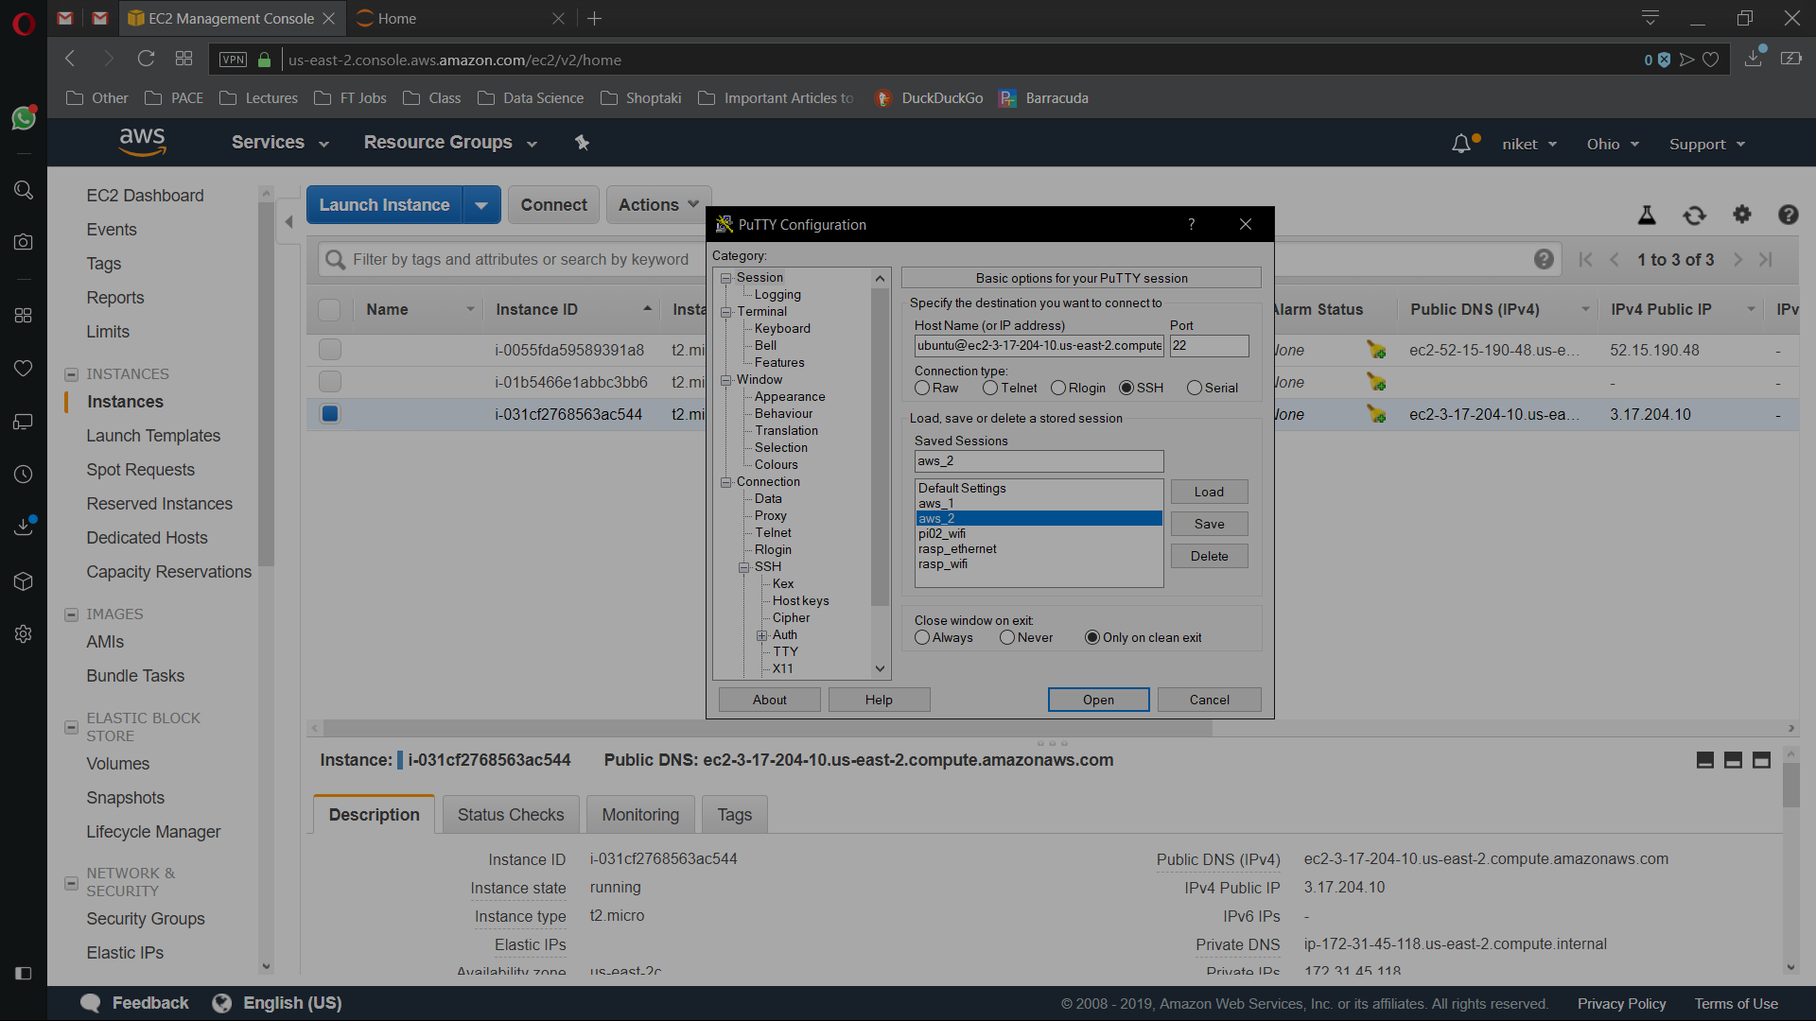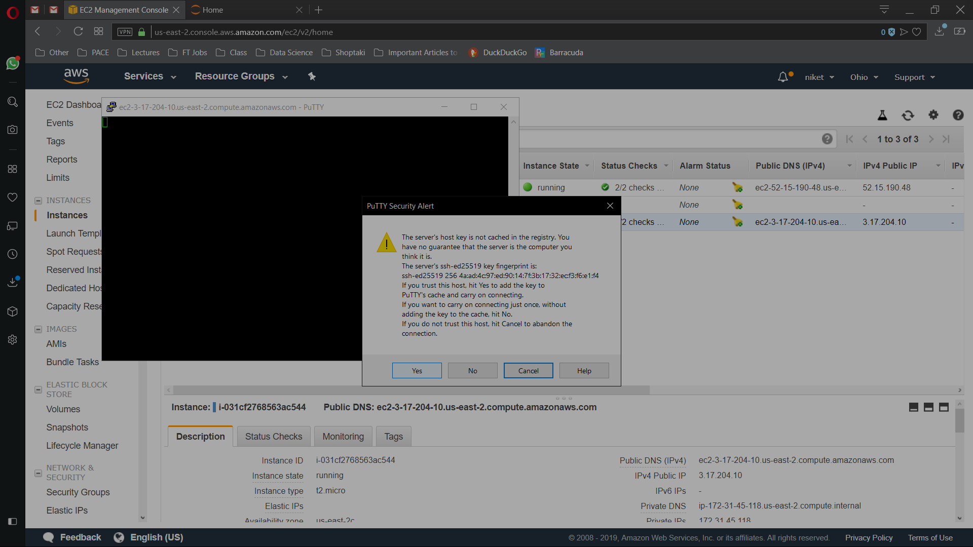

**Download Anaconda 3 installer**

wget <https://repo.continuum.io/archive/Anaconda3-4.4.0-Linux-x86_64.sh>

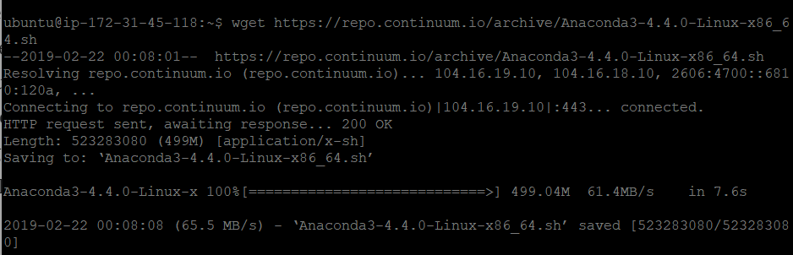

**Install Anaconda3 by typing:**

bash Anaconda3-4.4.0-Linux-x86_64.sh



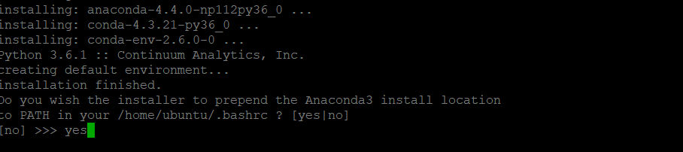

To switch your environment to use Python 3 type the command:

which python /usr/bin/python

source .bashrc

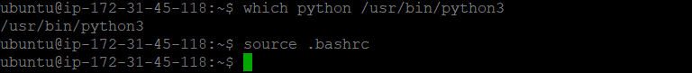

**Create your Jupyter/Ipython password:**

ipython

from IPython.lib import passwd

passwd()

**save your SHA hash for future reference by copying and pasting it to a text file, you’ll need this later**

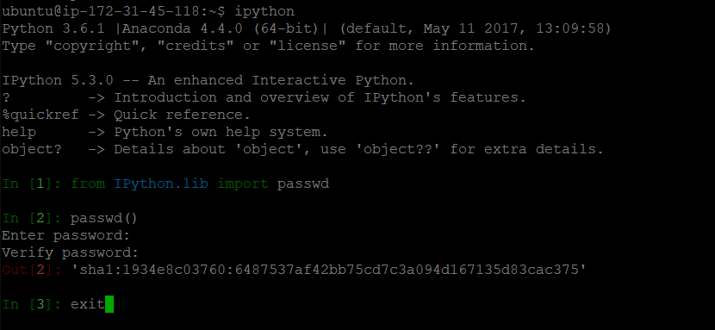

sha1:1934e8c03760:6487537af42bb75cd7c3a094d167135d83cac375

**Configure Jupyter/Ipython server to access your notebooks from local computer via internet browser:**

jupyter notebook --generate-config



Generate key & cert into the jupyter configuration folder:

openssl req -x509 -nodes -days 365 -newkey rsa:1024 -keyout ~/.jupyter/key.key -out ~/.jupyter/cert.pem

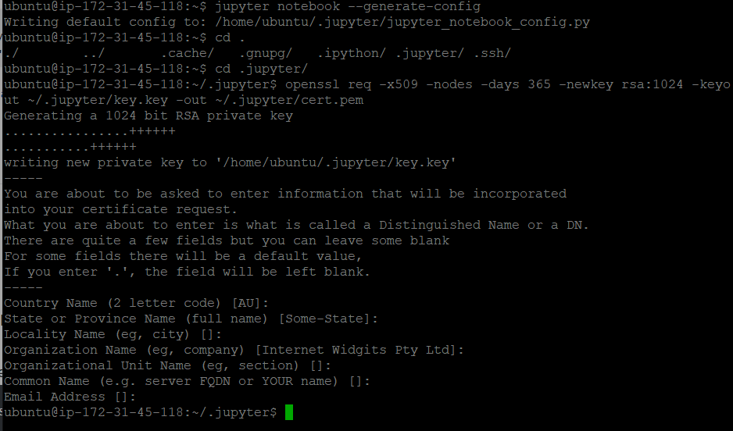

**Edit your Jupyter configuration file:**

nano .jupyter/jupyter_notebook_config.py



c = get_config()  
  
# Kernel config  
c.IPKernelApp.pylab = 'inline' # if you want plotting support always in your notebook  
  
# Notebook config  
import os

c.NotebookApp.keyfile = os.path.expanduser('~') + '/.jupyter/key.key'

c.NotebookApp.certfile = os.path.expanduser('~') + '/.jupyter/cert.pem'

#location of your certificate file  
c.NotebookApp.ip = '0.0.0.0'  
c.NotebookApp.open_browser = False #so that the ipython notebook does not opens up a browser by default  
c.NotebookApp.password = u' sha1:1934e8c03760:6487537af42bb75cd7c3a094d167135d83cac375' #edit this with the SHA hash that you generated after typing in Step 9  
# This is the port we opened in Step 3.  
c.NotebookApp.port = 8081

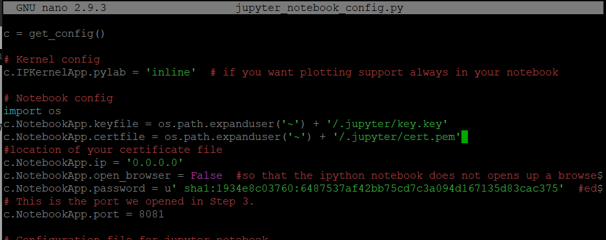

**Create a folder for your notebooks and start Jupyter Notebook:**

mkdir Notebooks  
cd Notebooks

jupyter notebook

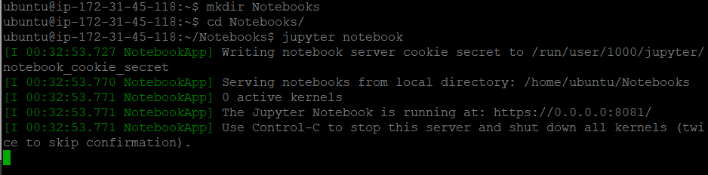

In browser:

<https://ec2-3-17-204-10.us-east-2.compute.amazonaws.com:8081/>

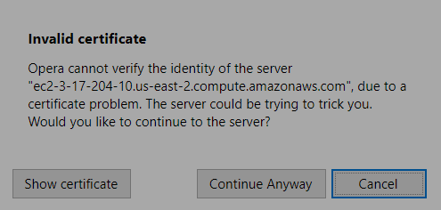

Click Continue Anyway

